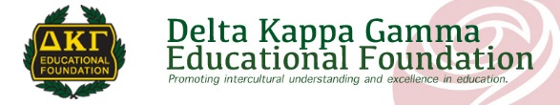


BEAR Program Overview

The BEAR Program was designed following the Sibling Reading Buddies Program created by Alan deMeurers, a principal in the Salem-Keizer School District. Alan found a way to promote family literacy through book donations and literacy support to students and their families who have just welcomed a new-born brother or sister into the family. When a new child is born in the family, the student sibling(s) is acknowledged in an all school assembly, takes a pledge of literacy with the principal, and receives a special backpack. The backpack includes books, a letter from the principal to the new family about the importance of reading aloud, tips and guidance on how to promote family reading time and a reading log. Alan tracked the readers’ progress with photos, often making home visits, created a bulletin board to display photos and reading progress, and helped families network later to exchange and share books.
In partnership with Klamath Falls Alpha Chapter of The Delta Kappa Gamma Society International and Mills Elementary School, The Delta Kappa Gamma Educational Foundation and the Oregon State DKG Organization is pleased to support the expansion of this innovative promising practice in the Klamath Falls area under the BEAR Program.

In the school’s tub for the BEAR Programs is:
- a notebook with a flash drive of all materials to print, a copy of most items printed and two DVD’s prepared by Multnomah County Public Library that models family read aloud practices in English and Spanish; ;
- 25 special backpacks filled with 2 books for the new baby, a stuffed bear buddy, Clifford's Reading Tips for Parents and a flyer listing of “Milestones of Early Literacy Development;
- and a box of extra books for each sibling in the family to have one.

